Project Design Phase-II
Data Flow Diagram & User Stories

Date | 2 February 2026
Team ID | LTVIP2026TMIDS65523
Project Name | Gemini Historical Artifact Description
Maximum Marks | 4 Marks

Data Flow Diagrams:
A Data Flow Diagram (DFD) is a traditional visual representation of the information flows within a system. A neat and clear DFD can depict the right amount of the system requirement graphically. It shows how data enters and leaves the system, what changes the information, and where data is stored.
Example:
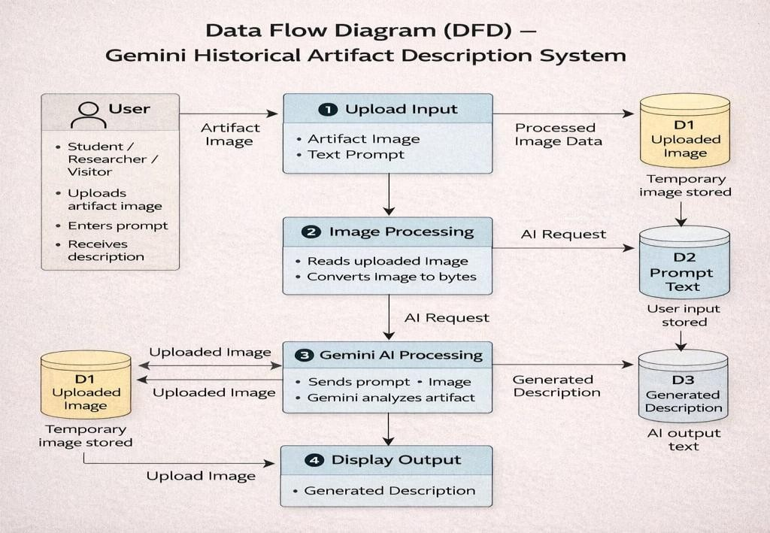
User Stories

User Type | Functional  Requirement  (Epic) | User Story  Number | User Story / Task | Acceptance criteria | Priority | Release
Customer (Web  User –  Student/Resear cher) | Access  Application | USN-1 | As a user, I can open the web application in my browser. | Application loads successfully and home  page is visible | High | Sprint-1
Customer (Web  User) | Upload Image | USN-2 | As a user, I can upload an image of a historical artifact. | Image preview is displayed after upload | High | Sprint-1
Customer (Web  User) | Enter Prompt | USN-3 | As a user, I can type an artifact name or description prompt. | Text input box accepts user input | High | Sprint-1
Customer (Web  User) | Generate Description | USN-4 | As a user, I can click “Generate Artifact Description” button. | AI generates and shows description on screen | High | Sprint-1
Customer (Web  User) | View Result | USN-5 | As a user, I can read the detailed historical description generated by AI. | Description includes origin, period, material, and  significance | High | Sprint-1
Customer (Web  User) | Interesting Fact | USN-6 | As a user, I can see a historical fact while the system is processing. | Historical fact message appears during loading | Medium | Sprint-2
Customer (Web user) | Error Handling | USN-7 | As a user, I get an error message if no image is uploaded. | System shows “No file uploaded” message | High | Sprint-1
Customer (Web  User) | API Configuration | USN-8 | As an admin, I can configure the Gemini API key securely. | API key stored in .env and system works | High | Sprint-1
Administrator | System Maintenance | USN-9 | As an admin, I can monitor the application and fix errors. | App runs without crash and generates output | Medium | Sprint-1
User Type | Functional  Requirement  (Epic) | User Story  Number | User Story / Task | Acceptance criteria | Priority | Release
Customer Care  Executive | User Help | USN-10 | As an admin, I can monitor the application and fix errors. | Users can successfully use the system after guidance | Low | Sprint-1

